INSTITUTE OF RURAL DEVELOPMENT PLANNING

DEPARTMENT OF ENVIRONMENTAL PLANNING
PUBLIC PARTICIPATION ON SOLID WASTE MANAGEMENT AT MKWAWA WARD IN IRINGA MUNICIPALITY
BY
LOVENESS RONALD MAKYAO
A DISSERTATION SUBMITTED IN PARTIAL FULFILLMENT FOR THE REQUIREMENTS OF THE AWARD OF BACHELOR DEGREE IN ENVIRONMENTAL PLANNING AND MANAGEMENT OF THE INSTITUTE OF RURAL DEVELOPMENT PLANNING, DODOMA, TANZANIA
SEPTEMBER 2025

ABSTRACT
This research was carried out at Mkwawa Ward with the aim of assessing public participation in solid waste management. The specific objectives were to examine categories of solid waste generated, to determine the extent of public participation in solid waste management activities, and to assess challenges facing public participation in solid waste management. The methods used in data collection were interviews, observation, and questionnaires, while data were analyzed using the Statistical Package for Social Sciences (SPSS). The research findings show that organic waste was the dominant type generated while plastics, paper, and electronic waste were produced in smaller amounts. The community actively engaged in waste reduction, reuse, and organization, but recycling was absent and formal partnerships were lacking. The main challenges included limited knowledge, weak communication channels, inadequate resources, and dissatisfaction with waste collection services. In conclusion, community willingness to participate in solid waste management exists but is constrained by systemic and infrastructural barriers. It is recommended that Iringa Municipal Council strengthen composting, recycling, and awareness programs while improving service delivery to enhance sustainable participation.

DECLARATION
I LOVENESS RONALD MAKYAO declare that this dissertation is my own original work and that it has not been presented to any other Institute for a similar or any other degree award Candidate name LOVENESS RONALD MAKYAO
Signature…………………………………………………... Date………………………………………………………...

COPYRIGHT
No part of this paper may be produced or transmitted in any form and by any means without permission of the writer or the Institute of Rural Development Planning

RESESRCH SUPERVISOR’S CERTIFICATION
I…………………………………………………… certify that I have read and hereby recommend for acceptance by the institute of Rural Development Planning the dissertation entitled Public Participation on Solid Waste Management at Mkwawa Ward in Iringa Municipality in fulfilment of the requirements for the bachelor degree in Environmental Planning and Management of the Institute of Rural Development Planning.
Name of the supervisor(s)…………………………………………...
Signature………………………………………………………...
Date………………………………………………………………….

ACKNOWLEDGEMENT
I am deeply grateful to the Almighty God of the heavens for His divine protection, guidance, and wisdom throughout this research journey. His unwavering support has been instrumental in the successful completion of this study. I extend my appreciation to my family for their unending love, understanding, support and prayers. Their encouragement and unwavering support have been a constant source of motivation, and I am grateful for their presence in my life.
I would like to express my sincere gratitude to the management of the IRDP (Institute of Research and Development Planning) for providing the platform and resources for this research program. I am indebted to Dr. Irene Regnard for his invaluable supervision and mentorship. His expertise, guidance, and constructive feedback have been instrumental in shaping the direction of this study. Special thanks go to Mr. Mafuru Juma for serving as the external supervisor. His insightful input and expertise added depth to the research and enriched its overall quality. I am thankful to the officials of the Mkwawa ward for their cooperation and assistance during the data collection process. Their support was crucial in acquiring the necessary information for this study.

TABLE OF CONTENTS
ABSTRACT i
DECLARATION ii
COPYRIGHT iii
RESESRCH SUPERVISOR’S CERTIFICATION iv
ACKNOWLEDGEMENT v
LIST OF TABLES x
LIST OF FIGURES xi
LIST OF APPENDICES xii
LIST OF ABBREVIATIONS AND ACRONYMS xiii
DEFINITION OF KEY TERMS xiv
CHAPTER ONE 1
1.0INTRODUCTION 1
1.1 Background Information 1
1.2 Statement of the Problem 3
1.3 Significance of a Study 3
1.4 Research Objectives 4
1.4.1 General objective 4
1.4.2 Specific objectives 4
1.5 Research Questions/ Hypotheses 5
1.6 Scope of the Study 5
CHAPTER TWO 7
2.0 LITERATURE REVIEW 7
2.1 Theoretical Review 7
2.1.1 Participatory Development Theory 7
2.1.2Theory of Planned Behavior 7
2.1.3Public Participation Theory 7
2.2 Empirical Review 8
2.2.1. Categories of solid wastes 8
2.2.2Public participation in solid waste management 8
2.2.3Challenges facing public participation in solid waste management 9
2.3 Information Gap 9
2.4. Conceptual Framework 10
CHAPTER THREE 12
3.0 RESEARCH METHODOLOGY 12
3.1 Study Area 12
3.2 Research Design 12
3.3 Data Types and Sources 13
3.3.1Data types 13
3.3.2 Data sources 13
3.4 Data Collection Methods and Tools 14
3.4.1Observation 14
3.4.2 Interview 14
3.4.3Documentary review 14
3.5 Sampling 14
3.5.1 Sampling Frame 14
3.5.2 Sampling Unit 14
3.5.3 Sampling Size 15
3.5.4 Sampling Procedures 15
3.6 Detailed Field Work 15
3.7 Data Processing, Analysis, and Presentation 16
3.7.1. Data Processing 16
3.7.2 Data Analysis 16
3.7.3 Data Presentation 16
CHAPTER FOUR 17
RESULTS AND DISCUSSION 17
4.1 Demographic information of Respondents 17
4.1.1 Sex of Respondents 17
4.1.2 Age of Respondents 17
4.1.3 Marital Status of Respondents 17
4.1.4 Education Level of Respondents 19
4.1.5 Household Size of Respondents 19
4.2 Categories of Solid Waste Generated at Mkwawa Ward 20
4.2.1 Types of Waste Generated and Sources 20
4.2.1 Organic waste 20
4.2.2 Plastic waste 20
4.2.3 Paper waste 21
4.2.4 Electronic waste 22
4.2.1.2 Sources of solid waste 22
4.2.2 Amount of Waste Generated 23
4.2.3 Frequency of Use of Plastic Bottles and Disposal Practices 24
4.2.3.1 Frequency of use of Plastic bottles 24
4.2.3.2 Disposal methods for plastic wastes 24
4.2.4 Organic Waste Disposal Practices 25
4.3 Extent of Public Participation in Solid Waste Management 26
4.3.1 Waste Reduction Behavior 26
4.3.2 Waste Organization and Reuse 27
4.3.3 Waste Separation and Recycling 28
4.3.4 Awareness of Legal Regulation on Solid Waste Management 28
4.3.5 Involvement in Solid Waste Management Partnership 29
4.3.6 Effectiveness of Government in Solid Waste Management 29
4.3.7 Perceptions of Public on the Importance of Participating in Different Solid Waste Management Activities 29
4.4 Challenges Facing Public Participation in Solid Waste Management at Mkwawa Ward 30
4.4.1 Inadequate Knowledge and Awareness 30
4.4.2 Limited Information Channels 30
4.4.3 Underestimated Cultural Barriers 31
4.4.4 Critical Resource Shortages 31
4.4.5 Service Dissatisfaction 31
CHAPTER FIVE 32
CONCLUSION AND RECOMMENDATIONS 32
5.1 Conclusion 32
5.2 Recommendations 33
REFFERENCES 34
APPENDICES 37

LIST OF TABLES
Table 1: Demographic information of the respondents 18
Table 2: Types of Solid Waste Generated 22
Table 3: Sources of Solid Waste 23
Table 4: Amount of Solid Waste Generated Weekly 23
Table 5: Frequency of Plastic Bottle Use 24
Table 6: Disposal Methods for Plastic Waste 25
Table 7: Frequency of Waste Reduction Practices 27
Table 8: Methods of Waste Minimization 27
Table 9: Frequency of Waste Organization 28
Table 10: Awareness of Legal Regulations on SWM 28
Table 11: Perceived Effectiveness of Government in SWM 29
Table 12: Challenges Facing Public Participation in Solid Waste Management 30

LIST OF FIGURES
Figure 1: Conceptual framework 11

LIST OF APPENDICES
APPENDIX 1: Research Questionnaire for the Head of Households at Mkwawa Ward 37
APPENDIX 2: RESEARCH QUESTIONNAIRE FOR THE KEY INFORMANTS 46
APPENDIX 3: OBSERVATION CHECKLIST 47

LIST OF ABBREVIATIONS AND ACRONYMS
SWM | : | Solid Waste Management
EEA | : | European Environment Agency
UNEP | : | United Nations Environment Program
EMA | : | Environmental Management Act
NGOs | : | Non-Governmental Organization
CBOs | : | Community Based Organization
URT | : | United Republic of Tanzania

DEFINITION OF KEY TERMS
Public participation refers to the process by which individuals and communities engage in decision making and implementation of activities that affect their environment, wellbeing, and development (UNEP, 2015)
Municipal Solid Waste (MSW) - Household and commercial waste generated within urban areas, including organic, plastic, paper, and sanitary materials, requiring systematic collection and disposal (United Republic of Tanzania, 2021).

CHAPTER ONE

1.0 INTRODUCTION

1.1 Background Information
Public participation refers to the process by which individuals and communities engage in decision making and implementation of activities that affect their environment, wellbeing, and development (UNEP, 2015). It includes involvement in planning, policymaking, implementation, and monitoring processes. Solid waste management (SWM) is a critical issue facing many urban areas worldwide, especially in developing countries where rapid urbanization and population growth have outpaced the capacity of local governments to manage waste effectively (UNEP,2015).
The Rio Declaration on Environment and Development (1992) emphasized the right of individuals to participate in environmental decision-making processes, marking a major milestone in mainstreaming public involvement in sustainability issues (United Nations, 1992). In developed countries such as Sweden and Canada, public participation has led to the development of more inclusive policies on forest management, waste reduction, and biodiversity protection. For instance, in Sweden, citizen input has been crucial in shaping national waste management strategies, leading to recycling rates above 90% (EEA, 2021).
In developing countries, solid waste management is considered to be one of the most serious environmental problems confronting most urban areas (Sinha et al, 2000). In most African countries, management of solid waste is the responsibility of local authorities, which have low capacity in terms of financial, operational, institutional structures, management, and inappropriate technologies, which affect the availability, or sustainability of solid waste management services. Recent events in major urban centres in Africa have shown that the problem of waste management has become serious that has aborted most efforts by city authorities to collect and dispose the generated solid wastes (John, 2015).
In Ghana, local assemblies have been empowered through decentralization to involve residents in sanitation, waste management, and climate resilience programs (Yeboah et al., 2023). Despite these efforts, many African governments still face challenges such as lack of awareness, inadequate resources, and weak institutional frameworks that hinder meaningful public engagement.
In Tanzania, solid waste management has become a national priority, especially with increasing threats like open dumping and illegal dumping of wastes. The Environmental Management Act of 2004 underscores public participation as a critical element of environmental governance (EMA, 2004).
Iringa Municipal Council Annual report, (2023) indicated that the average solid waste generation per day was 55.66 tonnes while the capacity of collection for disposal per day was 13.3 (24%) tones. This implies that 42.36 tones (76%) of solid waste produced was not collected and disposed in a coordinated manner with the Municipal authorities. It was pointed out that lack of designated vehicles for solid waste disposal as currently they had only three vehicles and two vehicles it is used in multipurpose way as it is not designated for solid waste disposal only. Furthermore, low community participation in the cleaning day announced by the Municipal Council and inadequate fund allocated for solid waste management services are among the reasons that hamper solid waste management in Iringa Municipal Council. This contributes to public health and environmental problems due to the fact that the rate of waste produced does reflect with the effort made by the Municipal Council in an attempt to collect and dispose the waste. The comparative low enforcement of laws, by-laws and regulations on solid waste management is another challenge facing the Municipal Council in addressing solid waste management. However, there are different effort done to emphasize community and households to have willingness to pay for improved waste management services such as establishment of By-laws. This study aims to assess the public participation in Solid Waste Management (SWM) in Iringa municipal Council Tanzania.
At the household level there is no mechanism for waste sorting which make it difficult to minimize waste through recycling and safe disposal of waste including the hazardous ones (UN-HABITAT, 2006). Due to the threat posed by solid waste management in urban areas, Tanzania has set National Strategy for Growth and Reduction of Poverty (NSGRP) and health policy.
Mkwawa Ward, located within Iringa Municipality, is a rapidly urbanizing area characterized by a mix of residential, commercial, and institutional establishments. While the ward benefits from proximity to environmental protection agencies and educational institutions, it also faces issues like illegal dumping of waste. Although local environmental committees exist, the extent of public involvement in solid waste management programs efforts remains underexplored. Evidence suggests that while some residents participate in community clean-ups others remain disengaged, possibly due to lack of awareness, motivation, or structured platforms for engagement (Iringa Municipal Council, 2023).

1.2 Statement of the Problem
The management of solid waste at Mkwawa ward in Iringa municipality is characterized by significantly challenges that threaten public health and environmental sustainability. The rapid increase in population and urbanization has led to the increase in waste generation and overwhelming of the existing waste management systems. This led to the improper waste disposal practices such as open dumping and burning (Iringa municipal council, 2023)
Although frameworks exist to guide public involvement in environmental governances such as the formation of local environment committees and Ward Development Committees (WDC) their effectiveness depends largely on how actively and meaningfully the public participates in identifying and solving local environmental problems (Njonge, 2023).
Furthermore, there is limited empirical research focusing specifically on the contribution of public participation to solid waste management in local urban settings like Mkwawa Ward. Most existing studies are either national in scope or focus on rural areas, thereby leaving a knowledge gap on how urban communities participate in solid waste management programs and the effectiveness of such participation (Yeboah et al., 2023). Without a clear understanding of the barriers, motivations, and outcomes of public involvement at the grassroots level, policy interventions risk being top-down, poorly targeted, or unsustainable.
Despite, government, Non-governmental Organization and private sector coordinate effort to improve solid waste management as provided in Section 117 of the Environmental Management Act of 2004 R.E 2019. Therefore, this study seeks to assess the public participation in solid waste management at Mkwawa Ward focus on the level of awareness, the extent of involvement and challenges they face on their participation.

1.3 Significance of a Study
This study holds substantial significance both in academic and practical terms, as it aims to deepen the understanding of public participation in solid waste management, particularly in an urban Tanzanian context.
The findings of the study will offer valuable input to policymakers, particularly at the municipal and ward levels. Local government authorities, such as the Iringa Municipal Council, can use the results to identify existing barriers to effective public participation and design more inclusive and context-sensitive environmental programs. For example, if the study reveals that lack of awareness is a key challenge, the council could prioritize environmental education and awareness campaigns.
The study will benefit environmental stakeholders, including NGOs, community-based organizations (CBOs), and environmental committees operating in Iringa. These stakeholders often play a supporting role in mobilizing community action and advocating for policy changes. By understanding the levels and forms of participation among the local population, these groups can better tailor their interventions to enhance public engagement and stewardship.
The local residents of Mkwawa Ward will benefit indirectly through the improvement of environmental initiatives and increased attention to their needs and potential contributions. Empowering residents to take part in solid waste management programs can foster a sense of ownership, responsibility, and long-term commitment to sustainability. For example, when communities are involved in waste segregation or recycling activities, they are more likely to support and maintain such initiatives over time.
The study is expected to have a multi-level impact informing academic discourse, guiding policy formulation, strengthening stakeholder engagement, and empowering local communities to become active agents of environmental conservation through participating in solid waste management programs.

1.4 Research Objectives

1.4.1 General objective
The general objective of this study is to assess the public participation in solid waste management at Mkwawa Ward in Iringa Municipality.

1.4.2 Specific objectives
- To examine categories of solid waste generated at Mkwawa ward
- To determine the extent of public participation in solid waste Management activities at Mkwawa ward
- To assess the challenges facing public participation in solid waste management at Mkwawa ward

1.5 Research Questions/ Hypotheses
- What are the predominant categories of solid waste generated in Mkwawa ward?
Variables
- Plastic wastes
- Organic wastes
- Hazardous wastes
- Inorganic wastes
- Papers
- What extent do residents of Mkwawa participate in solid waste activities?
Variables
- Waste minimization
- Good housekeeping practices
- Reuse, recycling
- Legal disposal of waste
- Collaboration
- What are the main challenges hindering public participation in solid waste management in Mkwawa ward?
- Educational capacity
- Separation of wastes
- Cultural attitudes
- Resource availability
- Political will
- Willingness to pay

1.6 Scope of the Study
This study focuses on assessing the public participation on solid waste management within Mkwawa Ward, located in Iringa Municipality, Tanzania. Geographically, the study is limited to this ward due to its mixed urban characteristics and rapid population growth.
Thematically, the research will cover three main areas: categories of solid waste generated, and extent of public participation, challenges hindering effective involvement. The target population includes residents of Mkwawa Ward, local leaders, environmental committee members, and officials from Iringa Municipal Council. Data collection will be based on both qualitative and quantitative approaches, limited to the time and resources available to the researcher.
Temporally, the study will focus on the current practices and challenges of public participation, with a reference period of the last five years to understand recent trends and developments in solid waste management activities within the ward.

CHAPTER TWO

2.0 LITERATURE REVIEW

2.1 Theoretical Review

2.1.1 Participatory Development Theory
Participatory Development Theory states that sustainable development can only be achieved when local communities are actively involved in planning, implementing, and monitoring activities that affect their lives (Chambers, 1994). According to this theory, community participation is not only a right but also a necessity for achieving long-lasting outcomes. The theory supports the notion that when people are empowered to take part in solid waste management activities, they become more responsible, aware, and committed to protecting their local environment. In the context of Mkwawa Ward, this theory underpins the study by highlighting the need for grassroots engagement in solving solid waste management issues such as poor disposal and illegal dumping of the solid wastes

2.1.2Theory of Planned Behavior
The Theory of Planned Behavior (TPB) (Ajzen, 1991) explains how human behavior is guided by three factors: attitudes toward the behavior, subjective norms, and perceived behavioral control. In solid waste management, a person’s intention to participate in activities such as waste collection, segregation and sorting is influenced by their beliefs, social pressure, and their confidence in being able to perform the behavior. This theory is useful in explaining why some residents participate actively in solid waste management activities while others remain passive. It also informs the development of strategies to influence behavior through awareness, motivation, and enabling environments.

2.1.3Public Participation Theory
This theory emphasizes on the role of citizen in decision making processes. Arnstein’s Ladder of Citizen Participation (1969) categorizes participation in eight levels, ranging from manipulation to citizen control. The theory posits that public services can be more effective when citizens are actively collaborating with government agencies. This collaboration can lead to improved services delivered and increase accountability.

Empirical Review

2.2.1. Categories of solid wastes
The categories of solid waste are crucial for effective waste management strategies, there are various categories of solid waste including organic wastes, plastics, metals, paper and hazardous materials (URT, 2018).
The different categories of waste are obtained from different sources such as agriculture, market, institution, healthcare, construction and demolition. Study conducted in Dar es Salaam found that household wastes constitute approximately 75% and institution 0.5% markets 3.5% industry and commerce 20%and other sources is 0.5% (URT,2018)

2.2.2Public participation in solid waste management
A study in Nigeria found that community involvement in waste management initiatives led to increased awareness and behavioral change regarding waste disposal practices. The study highlighted the importance of local knowledge and community led initiatives in improving waste management outcomes (I. Sufiyan, 2020).
In Ghana the public participation in solid waste management not only improve waste collection efficiency but also fostered a sense of ownership among residents, leading to better compliance with waste management regulations (R. Nketsiah, 2022).
A study conducted in Lusaka - Zambia found that public participation improved waste collection efficiency and community satisfaction. The study shows that when communities are involved in planning, monitoring and implementation of the activities they are more likely to adhere to waste management regulations (Njonge, 2023).
A study conducted in Tanzania found that public participation has influence in change of attitudes and practices to embrace the concept of waste generators responsibilities by ensuring waste is appropriately managed at source and in all phases of management cycle also collaborate with other government entities and non-governmental organizations (URT, 2018)

2.2.3Challenges facing public participation in solid waste management
While public participation has many benefits, several studies have identified barriers to effective public participation in solid waste management.
Within Tanzania challenges such as lack of awareness, inadequate infrastructure, and limited government support as significantly impediments to community engagement in waste management (Augustino2015).
A study conducted in Dar es salaam found that while the willingness to participate in waste management existed, lack of education and awareness of solid waste by laws, lack of segregation of wastes, political interference on payment of waste collection fees and the cultural attitudes and poor attitudes of the public concerning solid waste management (URT, 2018).

2.3 Information Gap
Although numerous studies addressed the role of public participation in solid waste management have been generalized at national or regional levels, with limited attention toward level dynamics in specific urban settings like Mkwawa Ward in Iringa Municipality. There is inadequate localized evidence on how community members in such urbanizing areas engage and influence solid waste management efforts on the ground.
Previous research often focuses on formal policy frameworks or the role of government and institutions, leaving a significant gap regarding the actual participation of local communities, the effectiveness of their involvement, and the barriers they face in contributing to solid waste management activities (Mwakaje, 2019). This oversight creates a weak link between national strategies and grassroots action, making it hard to design inclusive and practical conservation policies.
Moreover, while public awareness campaigns and stakeholder engagement forums exist, there is little documentation of their outcomes and community perceptions, particularly in semi-urban settings where environmental issues are pressing but often overlooked in planning processes.
This study therefore seeks to fill that gap by exploring the challenges, and outcomes of public participation in solid waste management specifically at Mkwawa Ward, thereby generating context-specific data that can inform both policy and practice at the municipal and ward levels.

2.4. Conceptual Framework
A conceptual framework illustrates the relationship between the key variables in the study. This study is based on the understanding that public participation influences solid waste management through various intermediate processes. Independent Variables (categories of wastes) these are Plastic waste, Organic wastes, Hazardous wastes, Inorganic wastes, Waste minimization, Good housekeeping practices, Reuse, recycling, Legal disposal of waste, Collaborate with government and private sectors, Low educational capacity and awareness, Lack of segregation of wastes, Cultural attitudes, Resource availability and Political interference on payment of waste collection. These dimensions are derived from the questions like “What are the predominate categories of waste?”, “How does the community participate in planning and decision-making.?" and "How is environmental education provided?” while Intermediate Variables linked within public participation to outcomes. They are influenced by the independent variables and in turn influence the outcome: Community engagement, access to information, socioeconomic factors and cultural attitudes these emerge under the objective. Dependent Variable (Outcome – solid waste management). This represents the main goal or impact of the process: Reduction in waste generation increased recycling rates, improved cleanliness and sanitation and enhanced community satisfaction with waste management services.

INDEPENDENT VARIABLES

INTERMEDIATE VARIABLES
DEPENDENT VARIABLE
- Waste minimization
- Good housekeeping practices
- Reuse, recycling
- Legal disposal of waste
- Collaborate with government and private sectors
- Low educational capacity and awareness
- Lack of segregation of wastes
- Cultural attitudes
- Resource availability

Solid waste management
- Community engagement
- Socioeconomic factors
- Access to information
- Cultural attitudes

VARIABLES

Figure 1: Conceptual framework

CHAPTER THREE

3.0 RESEARCH METHODOLOGY

3.1 Study Area
The study will be conducted in Mkwawa Ward, located in Iringa Municipality, Tanzania. The area was selected due to rapid urbanization and population growth as a result lead to improper disposal of waste, illegal dumping and proliferation of waste in public space and inadequate public awareness on solid waste management. Socio-economically, Mkwawa Ward comprises a mixture of middle-income and low-income communities, which may influence the degree and nature of public involvement in solid waste management activities.
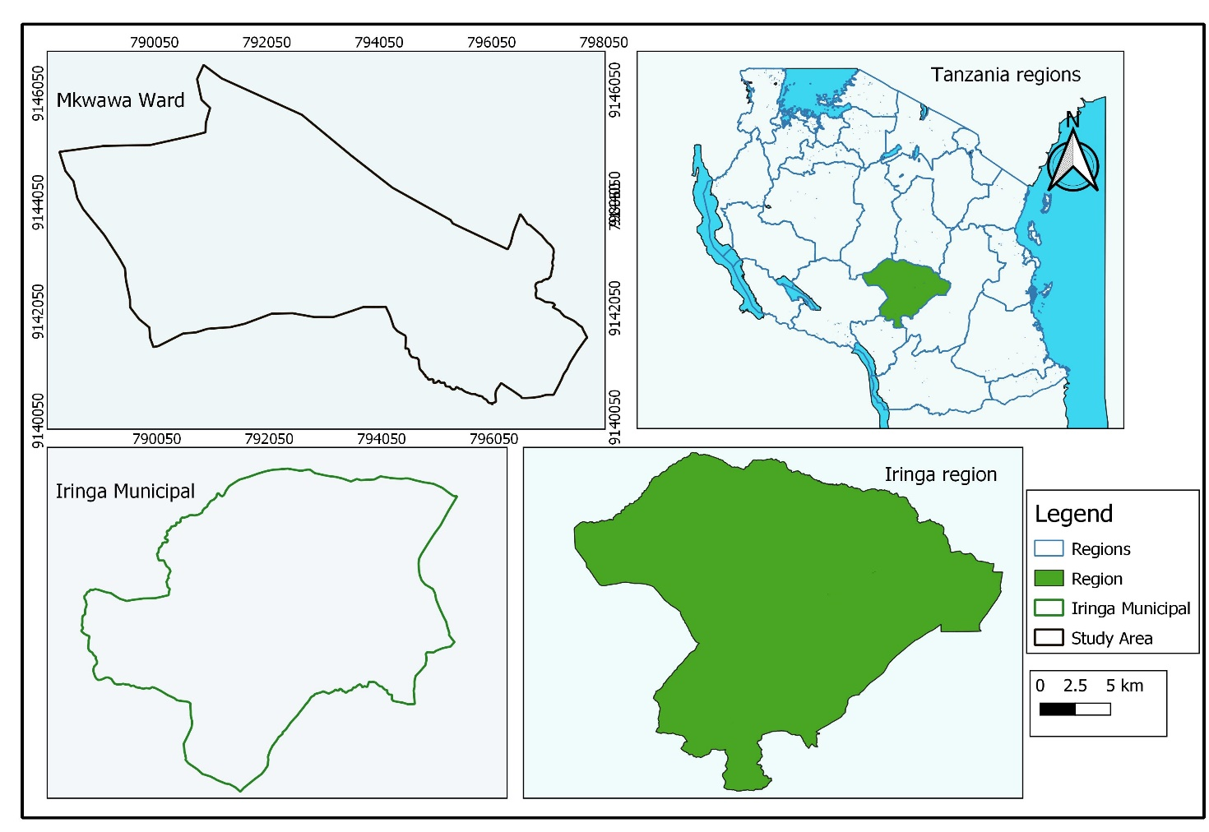
Figure 2: Location Map
Source: NBS, 2022.

3.2 Research Design
This study will employ a cross-sectional research design, which involves collecting data from a population at one point in time. This design is suitable for understanding the existing status and relationships between public participation and solid waste management without manipulating variables. It enables the study to analyze the views and actions of different groups within Mkwawa Ward, capturing diverse perspectives within a limited timeframe. The design allows the researcher to identify patterns, compare subgroups, and interpret findings relevant to solid waste management participation and its outcomes.

3.3 Data Types and Sources

3.3.1Data types

Quantitative data; are obtained through surveys and questionnaire where structured surveys can be distributed to residents to collect data on their waste disposal habits, awareness of waste management practices and participation in community initiatives. Local government can provide quantitative data on the volume and types of waste generated in Mkwawa ward.

Qualitative data; are obtained through interviews, focus groups and observational studies, conducting interviews with community leaders and local government officials can yield in depth insights into perceptions and attitudes related to waste management. Field observation to assess waste disposal practices and community engagement in clean-up activities.

3.3.2 Data sources
Primary data will be obtained directly from the field through questionnaires, interviews, and observation. These sources provide firsthand information from residents, local leaders, and environmental officials.
Secondary data will be gathered from municipal environmental reports, ward development plans, previous research studies, and relevant publications from government offices and NGOs working in the environmental sector. These data will provide background insights and complement the field findings.

3.4 Data Collection Methods and Tools

3.4.1Observation
Non participatory observation will be used to assess the way people engage in solid waste management activities in the ward and the level of community engagement during events. Tools such as checklists, diaries and camera s that will be used to capture visual records of observation including photographs and videos.

3.4.2 Interview
Semi-structured interviews will be conducted with ward officers, community leaders, and environmental stakeholders to gain deeper insight about what are the contribution of public participation on solid waste management activities and suggestions to improve public engagement.
Questionnaires: Structured questionnaires will be distributed to residents to gather data on knowledge, participation levels, challenges, and perceptions toward conservation.

3.4.3Documentary review
Environmental reports ward plans, NGO publications, policy document to get information about historical context of public participation initiatives and policy framework supporting public involvement.

3.5 Sampling

3.5.1 Sampling Frame
Is the complete list of all units or elements from which the sample was drawn from the population. The sampling frame includes all household of Mkwawa Ward, as well as local officials and environmental representatives involved in conservation efforts.

3.5.2 Sampling Unit
Refers to the individual elements or entities that are selected from the sampling frame for the study. The sampling unit will be individual household.

3.5.3 Sampling Size
The sample size is the number of sampling units selected from sampling frame to participate in the study. In this study the population is known, the sample size founded through below formula by Yamane, (1967)
N=N/ (1+N (e) ^2)
n=Estimated sample size
N=Number of household (according to census 2022) which is 4382
1=Constant
e=Margin of error which is 0.1
n=4382/1+4382(0.1) ^2
n=4382/1+4382(0.01)
n=97.7 estimated to 98

3.5.4 Sampling Procedures
Both probability sampling techniques will be employed, systematic sampling procedure will be used to select residents from various streets, ensuring each has an equal chance of being chosen.

3.6 Detailed Field Work
Prior to data collection, the researcher will obtain official permission from the Iringa Municipal Council and the Ward Executive Officer. Ethical clearance will also be sought where necessary. The researcher will train a few assistants (enumerators) on how to administer the questionnaires, conduct interviews, and handle data responsibly. The data collection process will be conducted over a period of two weeks. The researcher will ensure adherence to ethical principles including confidentiality, voluntary participation, and informed consent.

3.7 Data Processing, Analysis, and Presentation

3.7.1. Data Processing
The data processing would conduct by coding, categorizing, and entering it into Statistical Package for Social Sciences (SPSS) software to analysis data.

3.7.2 Data Analysis
The information will be computed by using Statistical package for Social Sciences (SPSS) in which percentages and frequencies are to be calculated.

3.7.3 Data Presentation
Data will be presented using tables, charts, and graphs for clarity. The analysis will also link back to the research objectives, drawing conclusions and providing recommendations base on findings,

CHAPTER FOUR

RESULTS AND DISCUSSION

4.1 Demographic information of Respondents
Results on demographic characteristics of respondents is shown in Table 1. The characters include sex, age, occupation, years that they have been living in the area and education level.

4.1.1 Sex of Respondents
As presented in Table 1, the gender composition was relatively balanced, with females representing 53.1% (52 respondents) and males 46.9% (46 respondents). This slight predominance of female participants may reflect women's traditional responsibilities in household waste handling and disposal in Tanzanian urban contexts, where they often manage daily cleaning and sorting activities (URT, 2018).

4.1.2 Age of Respondents
The age distribution, as shown in Table 1, indicates that the majority of respondents fell into the 36–45 age group (34.7%), closely followed by those aged 18–35 (32.7%), with smaller proportions in older brackets: 46–55 (15.3%), 56–65 (12.2%), and above 65 (5.1%). This youthful and middle-aged skew suggests that economically active adults are the primary waste generators and potential participants in SWM activities, driven by daily consumption patterns and family responsibilities.

4.1.3 Marital Status of Respondents
According to Table 1, married individuals dominated the sample at 69.4% (68 respondents), while singles accounted for 19.4% (19), divorced 5.1% (5), and widowed 6.1% (6). This prevalence of married respondent’s likely correlates with larger family units that generate higher waste volumes through shared household activities, underscoring the importance of family-level engagement in SWM. Such patterns align with Tanzanian empirical reviews, where public participation influences attitudes toward waste generator responsibilities, particularly in family settings (URT, 2018). Echoing findings from Ghana, where community involvement fostered ownership and better regulation compliance among households (Nketsiah, 2022), this distribution implies that strategies targeting married couples could amplify reuse and recycling practices. Nonetheless, including single and widowed individuals is crucial to avoid marginalization, promoting a holistic approach as advocated in Participatory Development Theory (Chambers, 1994), which emphasizes empowerment across all social structures for long-term sustainability.
Table 1: Demographic information of the respondents
Demographic characteristics | Frequency | Percentage (%)
Sex of respondents
Male | 46 | 46 .9
Female | 52 | 53.1
Age group of the respondents
18–35 | 32 | 32.7
36–45 | 34 | 34.7
46–55 | 15 | 15.3
56–65 | 12 | 12.2
Above 65 | 5 | 5.1
Marital status of the respondent
Single | 19 | 19.4
Married | 68 | 69.4
Divorced | 5 | 5.1
Widowed | 6 | 6.1
Education level
No Formal Education | 1 | 1.0
Primary Education | 29 | 29.6
Secondary Education | 30 | 30.6
College/University | 38 | 38.8
Household size
1–2 Members | 14 | 14.3
3–4 Members | 40 | 40.8
5–6 Members | 31 | 31.6
7 or More Members | 13 | 13.3

4.1.4 Education Level of Respondents
The educational profile, detailed in Table 1, reveals that 38.8% (38 respondents) had college or university education, 30.6% (30) secondary, 29.6% (29) primary, and only 1.0% (1) no formal education. This relatively high literacy level indicates potential for greater awareness and adoption of SWM practices, as education facilitates understanding of environmental policies and behaviours. These findings are in line with the Theory of Planned Behavior (Ajzen, 1991), where subjective norms and control perceptions are stronger among educated groups, leading to active participation. In contrast to barriers like low awareness in Dar es Salaam (Augustino, 2015), Mkwawa Ward's educated populace could support initiatives similar to those in Nigeria, where knowledge led to improved disposal practices (Sufiyan, 2020). To capitalize on this, educational campaigns should build on existing capacities, integrating community-based organizations as seen in Zambian studies (Njonge, 2023), to overcome any remaining gaps and enhance overall public involvement.

4.1.5 Household Size of Respondents
As indicated in Table 1, medium-sized households were most common, with 40.8% (40 respondents) having 3–4 members and 31.6% (31) having 5–6 members, while smaller (1–2 members) and larger (7+ members) households comprised 14.3% (14) and 13.3% (13), respectively. Larger households typically produce more waste, exacerbating management challenges, but they also offer opportunities for collective participation in sorting and composting. This distribution mirrors patterns in urban Tanzania, where family size influences waste volumes and the need for household-level interventions (UN-HABITAT, 2006). Comparable to Ghanaian contexts, where public engagement improved efficiency among varied household structures (Yeboah et al., 2023), these results suggest tailoring programs to medium and large families to promote reuse and minimization, in keeping with Public Participation Theory (Arnstein, 1969), which stresses collaborative decision-making for effective outcomes.

4.2 Categories of Solid Waste Generated at Mkwawa Ward

4.2.1 Types of Waste Generated and Sources

4.2.1 Organic waste
At 76.7% (n=98), organic waste is the overwhelming category (Table 2). This is not surprising and aligns with national data (URT, 2018) and patterns seen in other developing urban areas, where household food scraps and agricultural refuse are dominant. This presents a major opportunity. As seen in successful community-led projects in Zambia (Njonge, 2023), focusing public education on home composting could transform this waste into a resource, reducing landfill burden and creating valuable compost.
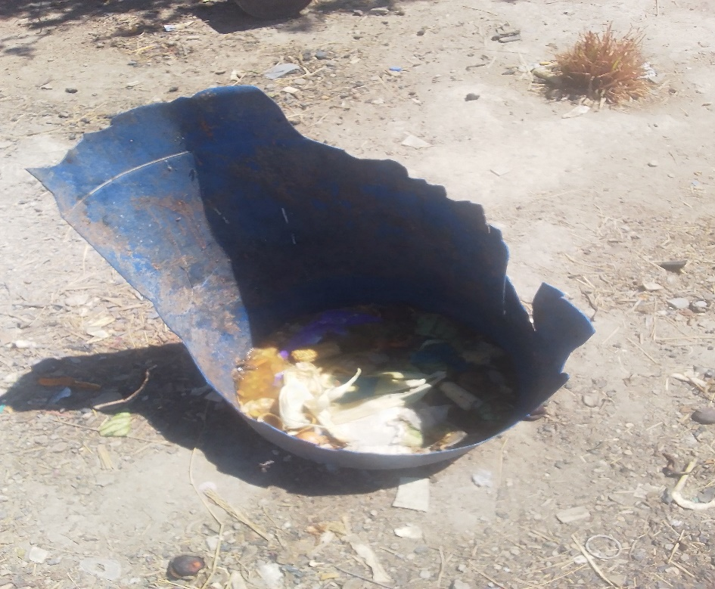
Plate 1: Waste stored in plastic bags

4.2.2 Plastic waste
Plastic is the second-most common waste at 14.7% (n=19) (Table 2), reflecting a global rise in packaged goods. This is a significant environmental concern due to its persistence. While slightly lower than some regional averages, its prevalence underscores an urgent need for policies targeting single-use plastics and improving local recycling chains to prevent pollution.
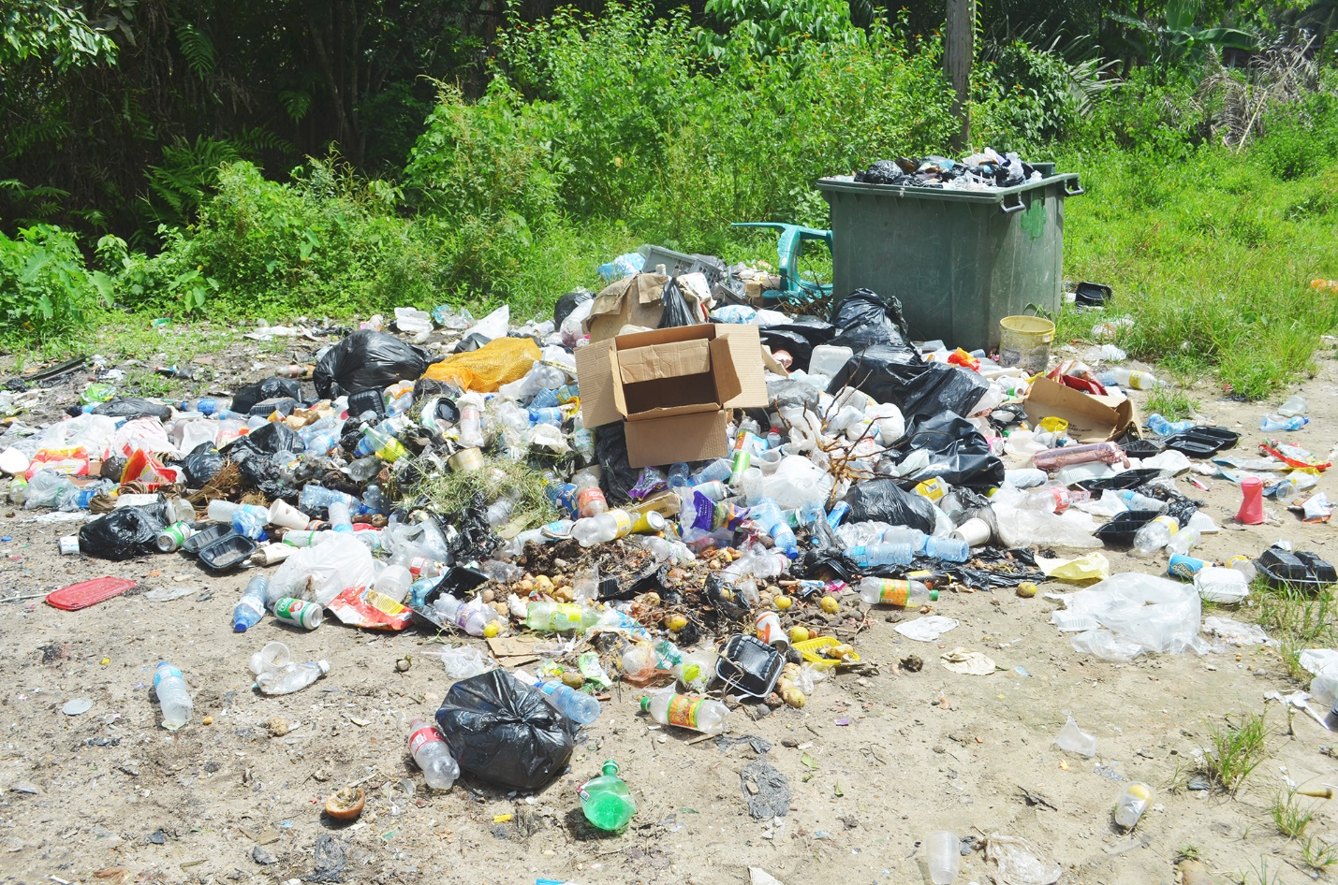
Plate 2: Waste stored in plastic bags

4.2.3 Paper waste
Paper makes up a smaller portion at 7.0% (n=9), as shown in Table 2. This is common in areas with less commercial packaging. The key challenge, as seen in similar contexts like Ghana (Miezah et al., 2015), is improving collection quality by reducing contamination with organic materials to make recycling feasible.

4.2.4 Electronic waste
E-waste was the smallest category at just 1.6% (n=2) (Table 2), but it is critically important. This low figure likely underestimates the problem, as e-waste is often stored or disposed of improperly. Even at this low level, its presence signals a growing future challenge. It demands specific strategies for safe collection and disposal to avoid the environmental hazards associated with its informal processing.

4.2.1.2 Sources of solid waste
Table 2: Types of Solid Waste Generated
Type of Waste | Frequencies | Percent (%)
Organic Waste | 98 | 76.7
Plastic Waste | 19 | 14.7
Paper Waste | 9 | 7.0
Electronic Waste | 2 | 1.6
Total | 128 | 100

Waste sources were led by households (71.5%, 98 responses), agriculture (19.7%, 27), and commercial activities (8.8%, 12), from 137 responses (Table 3). Household primacy reflects daily consumption, consistent with African urban challenges where local authorities struggle with collection (John, 2015). This echoes Sinha et al. (2000) on Asian experiences, adapted to Africa, suggesting household-centered interventions like those in Ghana for better segregation and reuse (Nketsiah, 2022), to integrate public efforts with municipal systems.
Table 3: Sources of Solid Waste
Source of Waste | Frequencies | Percent (%)
Household Activities | 98 | 71.5
Agricultural Activities | 27 | 19.7
Commercial Activities | 12 | 8.8
Household Activities | 98 | 71.5
Total | 137 | 100

4.2.2 Amount of Waste Generated
Weekly waste generation was moderate for most, with 49.0% (48 respondents) producing 5–10 kg and 40.8% (40) producing 11–20 kg, while extremes were low at less than 5 kg (8.2%, 8) and more than 20 kg (2.0%, 2), as per Table 4. This level strains limited municipal capacity, as noted in Iringa reports (Iringa Municipal Council, 2023), but offers scope for reduction through participation. Comparable to Nigerian studies where awareness reduced generation (Sufiyan, 2020), these findings support applying the Theory of Planned Behavior (Ajzen, 1991) to motivate behaviours like meal planning, enhancing sustainability in line with UNEP (2015) guidelines.
Table 4: Amount of Solid Waste Generated Weekly
Amount of Waste Generated | Frequencies | Percent (%)
Less than 5 kg | 8 | 8.2
5–10 kg | 48 | 49.0
11–20 kg | 40 | 40.8
More than 20 kg | 2 | 2.0

4.2.3 Frequency of Use of Plastic Bottles and Disposal Practices

4.2.3.1 Frequency of use of Plastic bottles
The findings indicate a culture of high-frequency plastic bottle use. As presented in Table 5, a striking 73.5% of the sample population uses plastic bottles either daily (32.7%, n=32) or several times a week (40.8%, n=40). This pattern of consumption is characteristic of rapidly urbanizing areas where convenience often trumps environmental consciousness. It reflects a global trend of increasing consumption of bottled beverages but is particularly acute in regions with limited tap water safety and accessibility (UNEP, 2021). This high usage rate directly translates into a substantial and continuous waste stream, establishing the scale of the disposal challenge.
Table 5: Frequency of Plastic Bottle Use
Frequency | Frequencies | Percent (%)
Daily | 32 | 32.7
Several Times a Week | 40 | 40.8
Weekly | 9 | 9.2
Rarely | 17 | 17.3

4.2.3.2 Disposal methods for plastic wastes
Disposal practices included throwing in trash (48.0%, 47), burning (37.8%, 37), reuse (10.2%, 10), and recycling (4.1%, 4) (Table 6). The high burning rate poses health risks, mirroring challenges in Dar es Salaam where poor attitudes hinder proper management (Augustino, 2015). This contrasts with positive reuse in Ghana (Nketsiah, 2022), suggesting awareness campaigns to shift behaviours toward recycling, per Participatory Development Theory (Chambers, 1994), to reduce pollution and promote community-led alternatives.

Table 6: Disposal Methods for Plastic Waste
Method | Frequencies | Percent (%)
Recycle | 4 | 4.1
Throw in Trash | 47 | 48.0
Reuse | 10 | 10.2
Burning | 37 | 37.8

4.2.4 Organic Waste Disposal Practices
Organic waste disposal showed 58.2% throwing in trash especially using plastic bags as shown in Plate 1, 22.0% feeding to animals, and 19.8% composting. Although not tabulated, this underutilization of composting highlights missed opportunities for sustainable practices, as identified in UN-HABITAT (2006). In Tanzania, where organic waste dominates, participation can change attitudes toward source management (URT, 2018), similar to Zambia's improved satisfaction through involvement (Njonge, 2023). Encouraging composting via education could align with global calls for public engagement (UNEP, 2015), reducing landfill reliance and enhancing environmental health.
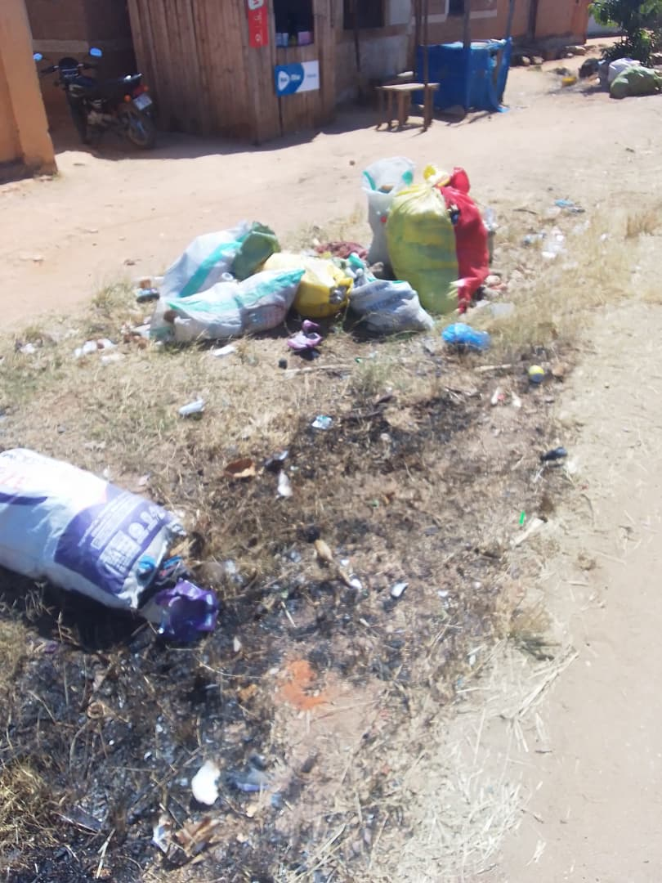
Plate 3: Waste stored in plastic bags

4.3 Extent of Public Participation in Solid Waste Management

4.3.1 Waste Reduction Behavior
Waste reduction was practiced regularly by 84.7% (daily 44.9%, several times a week 39.8%), with minimal non-engagement (15.4%), as in Table 7. Methods included buying in bulk (39.8%), avoiding single-use items (36.7%), and meal planning (23.5%) (Table 8). This engagement indicates positive intentions, aligned with the Theory of Planned Behavior (Ajzen, 1991), and parallels Nigerian outcomes where involvement increased awareness (Sufiyan, 2020). To sustain this, as per URT (2018), further motivation through community programs could address the minority's reluctance, fostering broader adoption similar to Zambian efficiency gains (Njonge, 2023).

Table 7: Frequency of Waste Reduction Practices
Response | Frequencies | Percent (%)
Daily | 44 | 44.9
Several times a week | 39 | 39.8
Weekly | 11 | 11.2
Monthly | 2 | 2.0
Never | 2 | 2.0

Table 8: Methods of Waste Minimization
Waste Minimization Method | Frequencies | Percent (%)
Buying in bulk | 39 | 39.8
Avoiding single-use products | 36 | 36.7
Planning meals to reduce food waste | 23 | 23.5

4.3.2 Waste Organization and Reuse
Regular waste organization was evident, with 41.8% weekly and 34.7% daily (Table 9). Reuse was adopted by 72.4%, primarily plastic bags (70.5%), clothes (19.7%), and glass (9.8%). This promotes resource conservation, consistent with good housekeeping in Participatory Development Theory (Chambers, 1994), and reduces pollution as in Sinha et al. (2000). Building on this, like Ghana's sense of ownership (Nketsiah, 2022), could expand practices to combat illegal dumping noted in Iringa (Iringa Municipal Council, 2023).

Table 9: Frequency of Waste Organization
Frequency | Frequencies | Percent (%)
Daily | 34 | 34.7
Weekly | 41 | 41.8
Monthly | 11 | 11.2
Rarely | 12 | 12.2

4.3.3 Waste Separation and Recycling
Separation was high at 81.6%, facilitating better management per UNEP (2015), but recycling was non-existent (100% never). This infrastructure gap limits effectiveness, as in Augustino (2015), contrasting with Ghana's policy-making involvement (Nketsiah, 2022). Investments in facilities, guided by Arnstein's (1969) collaboration levels, could elevate participation to match successful models.

4.3.4 Awareness of Legal Regulation on Solid Waste Management
Legal awareness was moderate at 58.2% (Table 10), focusing on fines, fees, and legislation. This level supports enforcement but reveals gaps, per EMA (2004), similar to Tanzania's challenges with by-laws (URT, 2018). Enhancing knowledge through campaigns, as in Zambia (Njonge, 2023), would strengthen compliance and public roles.
Table 10: Awareness of Legal Regulations on SWM
Response | Frequencies | Percent (%)
Yes | 57 | 58.2
No | 41 | 41.8

4.3.5 Involvement in Solid Waste Management Partnership
No partnerships were reported (100%), indicating missed collaborations with government and NGOs. This hampers resource sharing, per Chambers (1994), and mirrors institutional weaknesses (John, 2015). Adopting Ghana's decentralization (Yeboah et al., 2023) could build capacity and mobilize communities.

4.3.6 Effectiveness of Government in Solid Waste Management
Government was seen as effective by 60.2% (very effective 17.3%, effective 42.9%), neutral by 34.7%, and ineffective by 5.1% (Table 11). Positive views acknowledge efforts, but neutrality suggests visibility issues, akin to African capacity limits (Yeboah et al., 2023). Improving accountability, per Arnstein (1969), would boost trust and participation.
Table 11: Perceived Effectiveness of Government in SWM
Response | Frequencies | Percent (%)
Very effective | 17 | 17.3
Effective | 42 | 42.9
Neutral | 34 | 34.7
Ineffective | 5 | 5.1

4.3.7 Perceptions of Public on the Importance of Participating in Different Solid Waste Management Activities
High importance was attributed to separation (92.9%), recycling (89.8%), and collection (96.9%), reflecting awareness per Ajzen (1991). Payment views were divided (47.9% positive, 31.5% negative), due to service issues as in URT (2018). Transparency, like in Nigeria (Sufiyan, 2020), could improve willingness and sustain engagement.

4.4 Challenges Facing Public Participation in Solid Waste Management at Mkwawa Ward

4.4.1 Inadequate Knowledge and Awareness
The study reveals significant knowledge gaps, with only 44.9% of respondents demonstrating good waste management knowledge. This finding aligns with Mato's (1999) research in Dar es Salaam, where inadequate awareness was identified as a primary barrier to waste separation and recycling. The heavy reliance on community meetings (64.3%) excludes many residents, particularly working adults, while minimal NGO involvement (1.0%) limits expert input. These knowledge deficiencies directly impact participation rates, as residents cannot practice what they do not understand.
Table 12: Challenges Facing Public Participation in Solid Waste Management
Challenge Category | Frequency | Percentage (%)
Inadequate Knowledge and Awareness | 50 | 51
Limited Information Channels | 63 | 64.3
Underestimated Cultural Barriers | 69 | 70.4
Service Dissatisfaction | 67 | 68.3
Critical Resource Shortages | 73 | 74.5

4.4.2 Limited Information Channels
The overwhelming dependence on community meetings (64.3%) creates accessibility barriers, while underutilization of social media (21.4%) misses opportunities to engage younger demographics. This pattern mirrors challenges observed by Kassim (2006) in Morogoro, where limited communication channels reduced participation in waste management programs. The near-absence of NGO involvement (1.0%) represents a missed opportunity for knowledge transfer and innovative approaches, ultimately restricting the effectiveness of awareness campaigns.

4.4.3 Underestimated Cultural Barriers
Despite 70.4% reporting minimal cultural influence, this perception itself constitutes a challenge. As noted by Mwanza (2003), cultural factors often operate subconsciously in Tanzanian communities, influencing waste disposal habits through traditional practices. The failure to acknowledge these influences may explain why some interventions prove ineffective, as they fail to address deep-rooted behaviors that contradict modern waste management approaches.

4.4.4 Critical Resource Shortages
The severe shortage of collection services (74.5%) and bins (20.4%) represents the most pressing challenge. These findings corroborate Kaseva's (2002) study in Dar es Salaam, where inadequate infrastructure was identified as the primary barrier to community participation. Without basic resources, residents cannot effectively separate or store waste, leading to frustration and disengagement from management initiatives.

4.4.5 Service Dissatisfaction
The high dissatisfaction rate (76.6% combined) reflects broader systemic issues in service delivery. This finding echoes Kihila's (2014) research in Moshi, where poor service quality directly reduced willingness to participate in waste management programs. The dissatisfaction likely stems from irregular collection services and inadequate infrastructure, creating a cycle of poor performance and reduced community engagement.

CHAPTER FIVE

CONCLUSION AND RECOMMENDATIONS

5.1 Conclusion
The study revealed that organic waste constitutes the dominant category of solid waste generated in Mkwawa Ward, presenting both a challenge and an opportunity for sustainable management. This finding underscores the critical need for targeted composting initiatives and organic waste diversion strategies that could significantly reduce pressure on landfill sites while creating valuable agricultural inputs. The substantial presence of plastic waste, coupled with inadequate disposal practices, highlights an urgent need for policy interventions targeting single-use plastics and improving local recycling infrastructure to mitigate environmental pollution.
Regarding public participation, the research demonstrated strong community engagement in waste reduction and organization practices, with residents actively implementing various minimization strategies. However, the complete absence of recycling facilities and formal partnerships represents a significant systemic gap that undermines these efforts. The high awareness of waste separation importance contrasted sharply with the lack of supporting infrastructure, indicating a crucial disconnect between community willingness and municipal capacity that must be addressed through coordinated planning and investment.
The study identified several critical barriers to effective participation, including knowledge gaps, limited information channels, and severe resource shortages. These challenges are compounded by widespread dissatisfaction with existing waste management services, creating a cycle of disengagement that hinders sustainable practices. Addressing these interconnected issues requires a comprehensive approach that combines infrastructure development, targeted education programs, and improved communication strategies to foster meaningful community involvement in solid waste management.

5.2 Recommendations
- The Iringa Municipal Council should prioritize the establishment of decentralized composting facilities and provide households with organic waste separation kits to capitalize on the high volume of organic waste, reducing landfill burden and creating valuable agricultural inputs.
- Municipal authorities should implement a comprehensive plastic waste reduction strategy that includes bans on single-use plastics, promotes affordable alternatives, and establishes accessible collection points to address the significant environmental threat posed by current disposal practices.
- Municipal authorities should develop integrated waste management partnerships that combine infrastructure improvements (collection services and recycling facilities) with transparent communication campaigns to build trust and demonstrate the tangible benefits of fee-based services, thereby increasing public willingness to participate and pay for improved waste management.

REFFERENCES
Ajzen, I. (1991). The theory of planned behavior. Organizational Behavior and Human Decision Processes, 50(2), 179–211. https://doi.org/10.1016/0749-5978(91)90020-T
Arnstein, S. R. (1969). A ladder of citizen participation. Journal of the American Institute of Planners, 35(4), 216–224. https://doi.org/10.1080/01944366908977225
Augustino, D. (2015). Public participation in solid waste management: A case of Dar es Salaam, Tanzania [Unpublished master's thesis]. University of Dar es Salaam.
Chambers, R. (1994). Participatory rural appraisal (PRA): Challenges, potentials and paradigm. World Development, 22(9), 1437–1454. https://doi.org/10.1016/0305-750X(94)90030-2
European Environment Agency (EEA). (2021). Waste recycling in Sweden. European Environment Agency.
Iringa Municipal Council. (2023). Annual environmental status report. Iringa Municipal Council.
John, J. A. (2015). Community participation in municipal solid waste management. In Urban Environmental Management (pp. 43-59). Sage Publications.
Kaseva, M. E. (2002). Infrastructure deficits and public participation in solid waste management in Dar es Salaam. Dar es Salaam University Press.
Kassim, S. M. (2006). Communication strategies for public participation in urban environmental management: The case of Morogoro, Tanzania. Nkuki na Nyota Publishers.
Kihila, J. M. (2014). Service quality and public willingness to participate in solid waste management: A case of Moshi Municipality [Unpublished doctoral dissertation]. University of Dodoma.
Mato, R. R. A. M. (1999). Public awareness and barriers to recycling in Dar es Salaam. Report for the World Bank.
Miezah, K., Obiri-Danso, K., Kádár, Z., Fei-Baffoe, B., & Mensah, M. Y. (2015). Municipal solid waste characterization and quantification as a measure towards effective waste management in Ghana. Waste Management, 46, 15–27. https://doi.org/10.1016/j.wasman.2015.09.009
Mwakaje, A. G. (2019). Challenges of environmental governance in rapidly urbanizing Tanzania. University of Dar es Salaam Press.
Mwanza, J. (2003). The role of culture in environmental management practices in Tanzania. Research on Poverty Alleviation (REPOA).
Njonge, T. (2023). Community engagement in solid waste management. International Journal of Research and Innovation in Social Science, 7(12), 1175–1189.
Nketsiah, R. (2022). Community participation in solid waste management policy-making process at the local government level in Cape Coast Metropolis. Journal of Local Government Studies, 4(1), 55–70.
Sinha, A. H. M. M., & Enayetullah, I. (2000). Community based solid waste management: The Asian experience. Waste Concern.
Sufiyan, I. (2020). Assessment of public participation on solid waste disposal in southern Kuduna State, Nigeria. Journal of Wastes and Biomass Management, 2(1), 15–18.
United Nations. (1992). Rio Declaration on Environment and Development. UN Doc. A/CONF.151/26 (Vol. I).
United Nations Environment Programme (UNEP). (2015). Guidelines for public participation in environmental matters. UNEP.
United Nations Environment Programme (UNEP). (2021). Global progress on drinking water and sanitation: Special focus on plastics in the environment. UNEP.
United Nations Human Settlements Programme (UN-HABITAT). (2006). Best practices for human settlements database. UN-HABITAT.
United Republic of Tanzania (URT). (2004). The Environmental Management Act No. 20 of 2004. Government Printer.
United Republic of Tanzania (URT). (2018). The National Solid Waste Management Strategy. Ministry of State, Vice President's Office, Union Affairs and Environment.
Yeboah, R., Akudugu, J. A., & Borkor, F. K. (2023). Decentralization and environmental governance in Ghana. African Journal of Governance and Development, 12(1), 22-45.

APPENDICES
RESEARCH QUESTIONNAIRE FOR THE HEAD OF HOUSEHOLDS AT MKWAWA WARD
Introduction
My name is LOVENESS MAKYAO a student of Institute of Rural Development Planning Undertaking Bachelor degree in Environmental planning and Management under the Department of Environmental Planning. I am conducting Research on the “Public participation on solid waste management at Mkwawa ward”. I am requesting you to answer the following questions.
The information you provide was confidentially used for this research only.
Date
Street
Ward
S/N
APPENDIX 1: Research Questionnaire for the Head of Households at Mkwawa Ward

APPENDIX 2: RESEARCH QUESTIONNAIRE FOR THE KEY INFORMANTSAPPENDIX 3: Research Questionnaire for the Head of Households at Mkwawa Ward
SECTION A: SOCIO – DEMOGRAPHIC INFORMATION
- Gender
- Male
- Female
- Age
- 18 – 35
- 36 – 45
- 46 – 55
- 56 – 65
- Above 65
- Marital status
- Single
- Married
- Divorced
- Widowed

- Education level
- None education
- Primary education
- Secondary education
- College/ University
- Household size
- 1-2 members
- 3-4 members
- 5-6 members
- 7 or more members
- Occupation …………………………….

SECTION B: THE CATEGORIES OF SOLID WASTE GENERATED
- What type of solid waste does your household generate?
- Organic wastes
- Plastic wastes
- Paper wastes
- Electronic wastes
- Others (specify)

- What are the primary sources of your solid wastes?
- Household activities
- Commercial activities
- Agriculture activities
- Others (specify)
- How much solid waste does your household generate per week?
- Less than 5 kg
- 5-10 kg
- 11-20 kg
- More than 20 kg
- Estimate the percentage of each type of waste generated in your household
- Organic waste…………….….%
- Plastic waste………………….%
- Paper waste…………………..%
- Electronic waste…………….%
- Other…………………………....%
- How frequently do you use plastic bottles?
- Daily
- Several times a week
- Weekly
- Rarely
- Never
- What do you do with plastic waste after use?
- Recycle
- Throw in trash
- Reuse
- Compost
- Burning
- Do you generate organic waste?
- Yes
- No
- If yes, how do you dispose organic waste?
- Composting
- Feeding animal
- Throwing in the trash
- Other
- How do you think is important to reduce waste in your community?
No | Categories of solid waste | Very important |  | Important |  | Neutral |  | Unimportant |  | Very unimportant
1 | Plastic waste
2 | Organic waste
3 | Hazardous waste
4 | Inorganic waste
5 | Papers

- Do you notice any seasonal variations in the amount of waste generated?
- Yes
- No
If yes explain………………………………………………………….

SECTION C: THE EXTENT OF PUBLIC PARTICIPATION IN SOLID WASTE MANAGEMENT
- How reduce the amount of waste you generate at home
- Always
- Sometimes
- Rarely
- Often
- Never
- what strategies do you use to minimize waste generation?
- Buying in bulk
- Avoiding single use products
- Planning meal to reduce food wastes
- Others (specify)
- How frequently do you clean and organize your waste storage area?
- Daily
- Weekly
- Monthly
- Rarely
- Never
- Do you reuse your items instead of throwing away?
- Yes
- No
- If yes, what type of items do you commonly reuse.
- Glass containers
- Plastic bags
- Old clothes
- Others (specify)
- Do you separate your waste into different categories?
- Yes
- No
- Are you aware of recycling facilities available for solid waste collection?
- Yes
- No
- How frequently do you recycle materials such as paper and plastic?
- Daily
- weekly
- Monthly
- Rarely
- Never
- Do you know the legal regulations regarding waste disposal in your area?
- Yes
- No
- If yes mention them…………………………………………………………………………
- Are you aware of any partnership and initiatives between local government and private sector for waste management?
- Yes
- No
- If yes mention them……………………………………………………………………………………….
- How would you rate the effectiveness of government initiatives in promoting solid waste management?
- Very effective
- Effective
- Neutral
- Ineffective
- Very ineffective
- How do you think it is important to participate in the following solid waste management activities?
NO | Important activities | Very important | Important | Neutral | Unimportant | Very unimportant
1 | Separation of waste
2 | Recycling of waste
3 | Collection of waste
4 | Payment of waste
5 | Re use of waste

- Do you believe that individual actions can make a difference in solid waste management?
- Yes
- No
SECTION D: WHAT CHALLENGES FACING PUBLIC PARTICIPATION IN SOLID WASTE MANAGEMENT
- How would you rate your knowledge about solid waste management?
- Very poor
- Poor
- Average
- Good
- Very good
- What source of information do you rely on for learning about waste management?
- Social media
- Community meetings
- Schools
- NGOs
- Other (specify)
- Do you practice waste segregation at home?
- Yes
- No
- If no what are the reason for not for segregating waste? List them ……………………..
- What do you think would encourage more people to segregate their waste?
- Education
- Incentives
- Community program
- Other (specify)
- How do cultural beliefs in your community influence attitudes towards waste management?
- Not at all
- A little
- Moderately
- Very much
- Are there any cultural practices that you believe hinder effective waste management?
- Yes
- No
If yes explain……………………………………………………………………………………………………….
- How do you think cultural attitudes can be changed to improve waste management practices?
- Education
- Policy changes
- Other (specify)
- What resources do you think are lacking in your community for better waste management?
- Bins
- Collection services
- Educational materials
- Other (specify)
- How would you rate the the availability of waste collection services in your area?
- Very poor
- Poor
- Average
- Good
- Very good
- Are you aware of any political issues affecting waste collection services in your community?
- Yes
- No
- If yes explain……………………………………………………………………………………………………………………
- How do you feel about the current payment systems for waste collection fees?
- Very unsatisfied
- Unsatisfied
- Neutral
- Satisfied
- Very satisfied

APPENDICES II: RESEARCH QUESTIONNAIRE FOR THE KEY INFORMANTS.
SECTION A: INSTITUIONAL ROLE
- What is your position …………………………………………………………
- What is your role in waste management………………………………………?
- How does your institution engage the public in waste activities?
………………………………………………………………………………….
- There are any existing policies for promoting public participation?
- Yes
- No
If yes, specify: …………………………………………………………….
- What challenges does the institution face in invssolving the public?
………………………………………………………………………………….
SECTION B: IMPACT AND STRATEGIES FOR IMPROVING PUBLIC PARTICIPATION IN SOLID WASTE MANAGEMENT
- Has public participation improved waste services?
APPENDIX 4: RESEARCH QUESTIONNAIRE FOR THE KEY INFORMANTS

APPENDIX 5: OBSERVATION CHECKLISTAPPENDIX 6: RESEARCH QUESTIONNAIRE FOR THE KEY INFORMANTS
- Yes
- No
- What measures do you think could improve waste management in your community?...........................................................................................
- What strategies do you recommend for increasing community involvement?
……………………………………………………………………………………..
- There are institutional structures effective in promoting participation?
- Yes
- No
If yes, specify: …………………………………………………………….

APPENDICES III: OBSERVATION CHECKLIST
Date
Street
Ward

- Public participation evidence
- Community clean-up events
- Public education posters
- Waste bins with instructions
- Community notice boards
- Institutional presence
- Local government waste trucks
- Staff wearing identifiable uniforms
APPENDIX 7: OBSERVATION CHECKLIST
- Scheduled waste collection seen
- Service quality
- Waste collection regularity
- Proper waste disposal areas
- Illegal dumping present
- Separation of waste at source

